Extra Duties in Next Year Payroll
There are two types of extra duties: Account Type S and Account Type G.
S Types are considered supplemental and not generally part of the work agreement. An example would be UIL sponsor. You may have hired the employee as a Math teacher. If he agrees to also be the UIL sponsor, we will pay him gratefully. But if he changes his mind, we will still keep him as a teacher and just re-assign the supplemental extra duty.
G Types, on the other hand, are generally considered part of their contract and included in the base contract. For example, we hire an employee to be a teacher AND coach. While the coaching part of their job may be considered extra, it comes as a package deal. If they can only coach or only teach, we are probably going to look for someone else.

Sign into File ID N

To Add an Extra Duty for the First Time -

Extra Duty Pay Code: Account Type S
The amount is a supplement to the employee’s salary and displayed as supplemental transactions on reports. Type S is not included in the employee’s contract total. It can be paid monthly or in one/two payments etc.
_____1. From Payroll > Maintenance > Staff Job/Pay Data > Pay Info Tab,
- Click on +Add.
- Use the ellipsis button to add the desired S Type Extra Duty under the Extra Duty Pay Code.
- The system will populate the Amount field based on the information provided in the Extra Duty table.
- Complete the Remaining Amount
- Complete the Remaining Payments fields.
Note: **Do not save at this time. You will need to complete information across the tabs before saving.
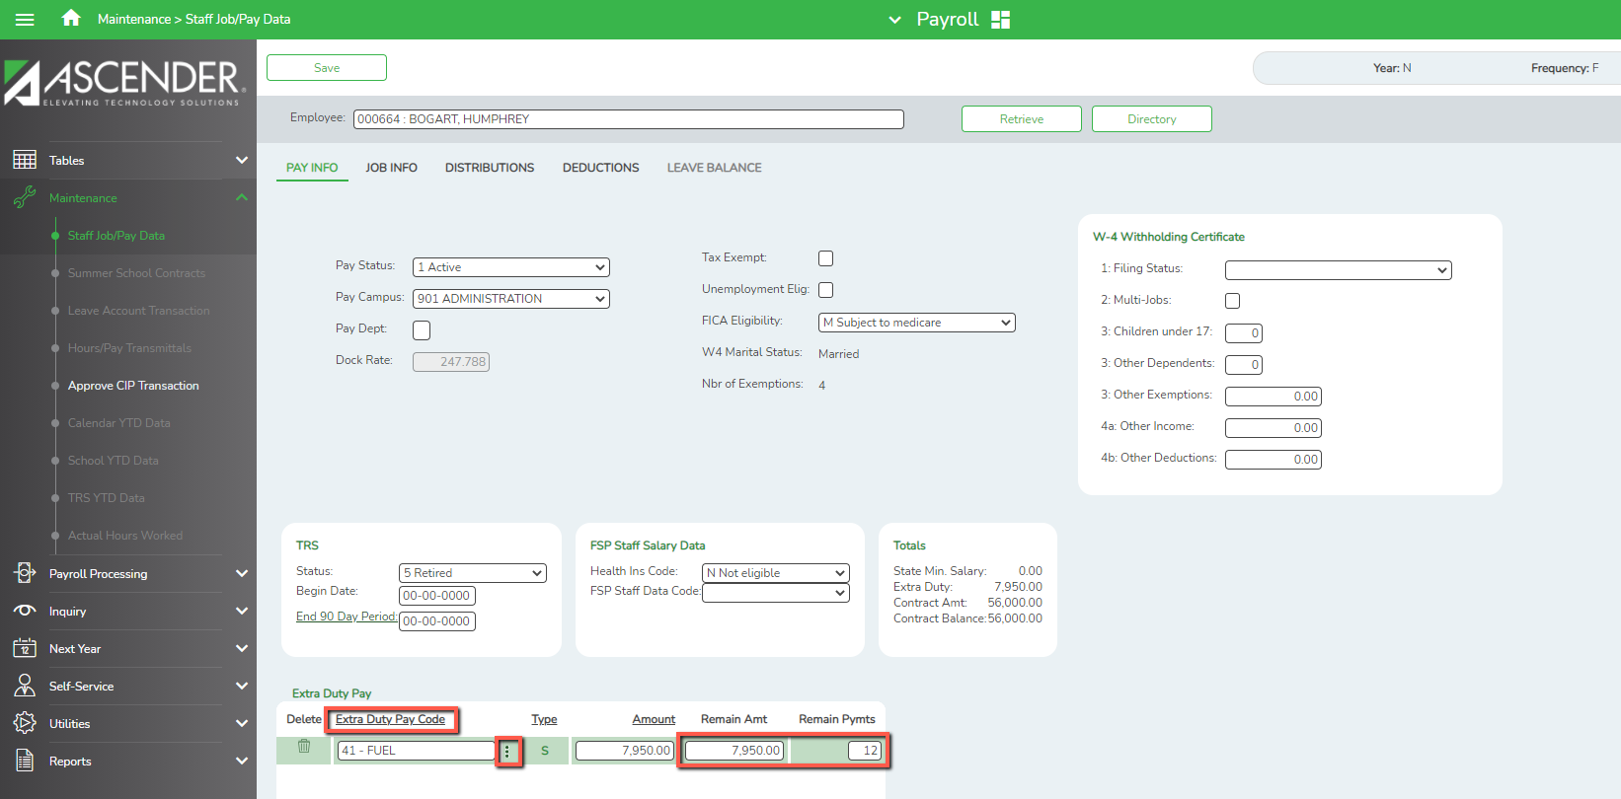
_____2. Verify that an “XTRA - Extra Duty” job is displayed at Maintenance > Staff Job/Pay Data > Job Info Tab. There is no need to complete any additional information on the Job Info tab.
Note: If multiple extra duty jobs are selected on the Pay Info tab, only one XTRA - Extra Duty job is displayed on the Job Info tab.
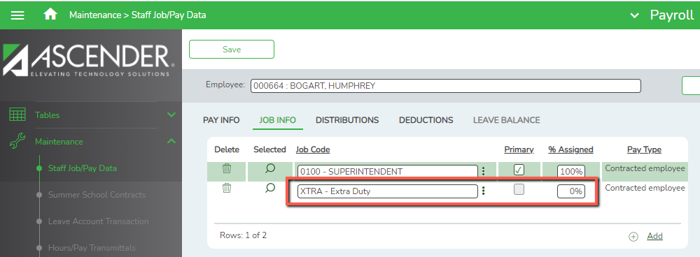

_____3. Add the distribution records for the extra duty job(s) from Maintenance > Staff Job/Pay Data > Distributions Tab.
- Click on +Add to add new row.
- From the Job Code drop-down list select XTRA- Extra Duty
- In the Extra Duty Code field, select the Extra Duty.
- If an Account Code was entered on the Extra Duty table, that Account Code will auto-populate but can be changed if desired. If no account code was entered into the Extra Duty table, enter the account code manually.
- Add the Extra Duty amount.
- Refresh totals
- Save the changes.

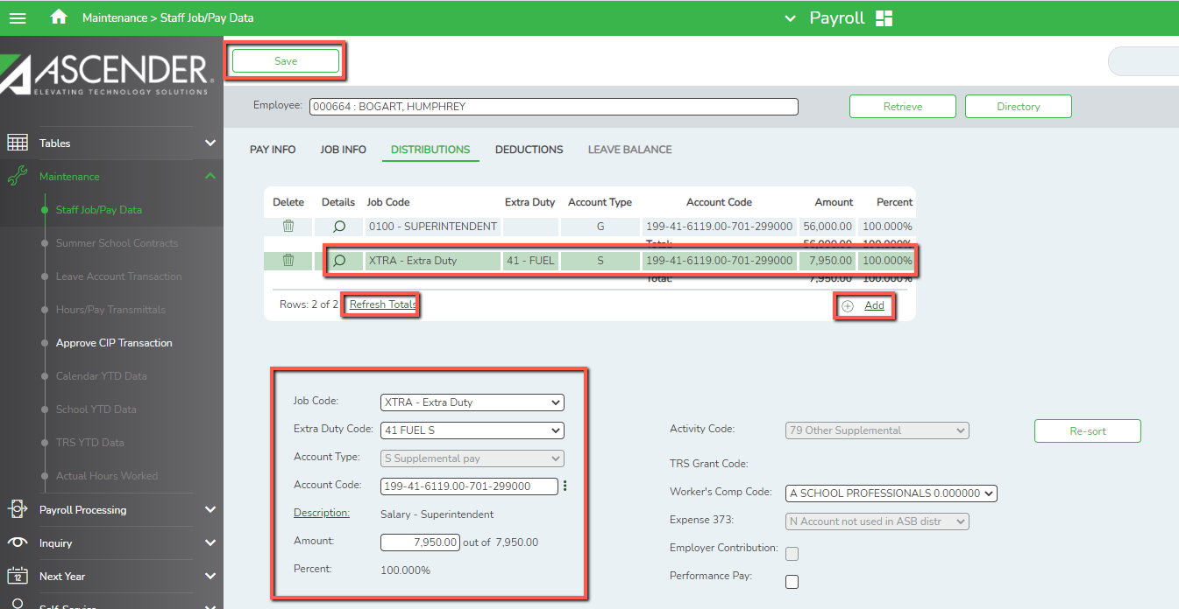
_____4. Determine whether the Extra Duty should be included in Above State Base calculations. If the Expense 373 field is selected on the Distributions tab, then the amount will be included in the Above State Base calculation and will be included in the distribution on the TRS 373 report. Summer School, Drivers’ Education, and Wholly Separate Jobs should not be included in Above State Base Calculations. Expense 373 should be selected for most other Extra Duties.

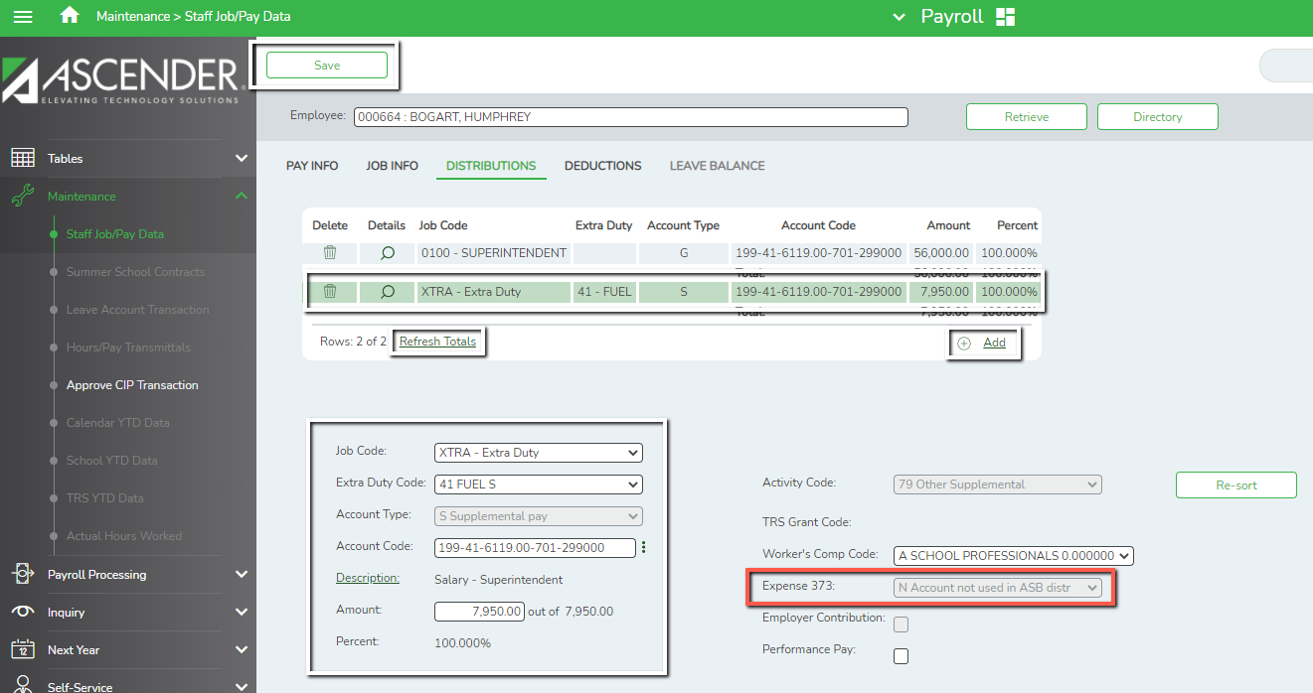

Notes:
The Expense 373 Eligibility is populated from the Extra Duty table, and is therefore grayed out. If Expense 373 needs to be changed in this instance, you must delete the extra duty, make the change on the Extra Duty table, and re-add.
TRS Member Positions were also selected on the Extra Duty Code table. If the employee is subject to Stat Min and the Extra Duty amount should be included in that calculation, the TRS Member Code must match. This may mean that you will need multiple Extra Duty Codes for the same type of stipend. For example, if you pay a $500 stipend to cheer sponsors. If the teacher is a sponsor for JV but a counselor is the sponsor for Varsity, 2 extra duty codes would be required. One tied to TRS position code 02, one tied to TRS position code 05.
The Account Type S amounts are displayed as supplemental transactions on the Payroll Earnings Register, Wage and Earnings Report, Calendar YTD, Addendum, and various other reports.
Remaining balances for XTRA - Extra Duty jobs that are Account Type S will be paid off when the primary job is in contract payoff.
Reminder: If the Type S extra duty is not paid monthly, reset the number of payments to zero before running the payroll until you are ready to pay the supplement.

Extra Duty Pay Code: Account Type G
_____5. From Payroll > Maintenance > Staff Job/Pay Data > Pay Info Tab,
- Click on +Add
- Use the ellipsis button to add the desired G Type Extra Duty.
- The amount will automatically populate.
- The Remaining Amount and Remaining Payments fields will not be accessible since the system will automatically distribute the amount equally over the course of the contract.
- Save

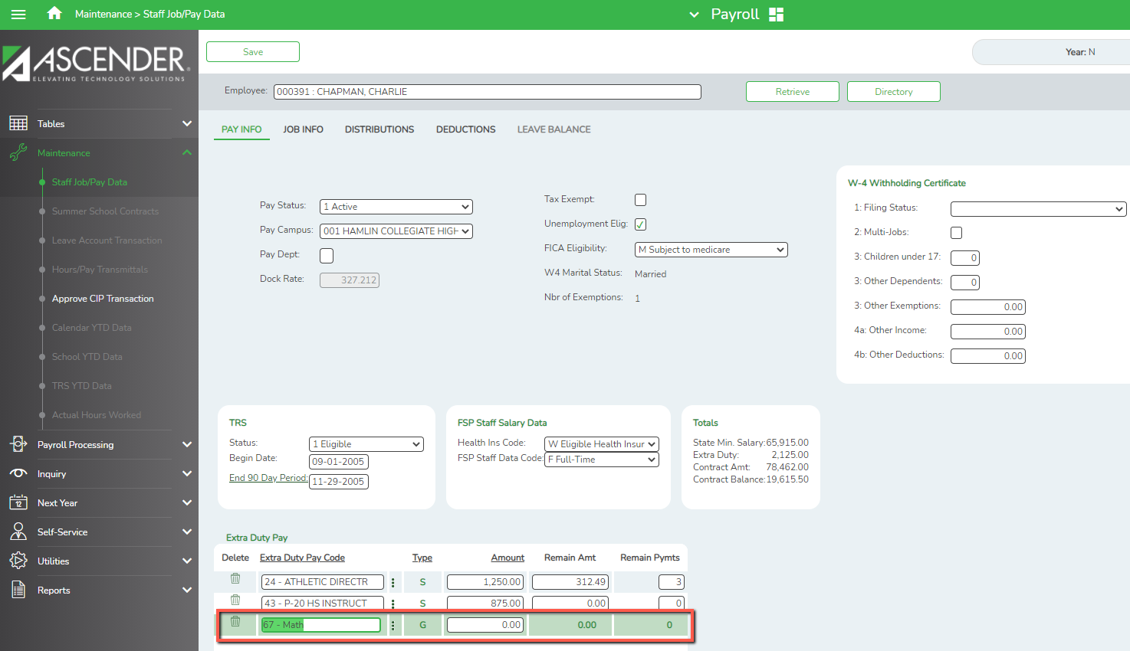

Note: Go to Tables > Salaries > Extra Duty to make any changes to the Extra Duty table.

_____6. Calculate to update the salary at Maintenance > Staff Job/Pay Data > Job Info tab. Unlike an Account Type S, Account Type G XTRA - Extra Duty jobs are not added to the Job Info tab.
- The only step needed on this tab is to calculate the employee’s salary using the Calculate button. Click on Calculate.
- The system will automatically add the extra duty amount to the contract total when salary calculations are done.

Note: This will only work if the employee is tied to salary tables and all fields tied to the tables are complete. If you do not perform salary calculations on the employee, the extra duty amount will need to be manually included in the Contract Total and Balance.
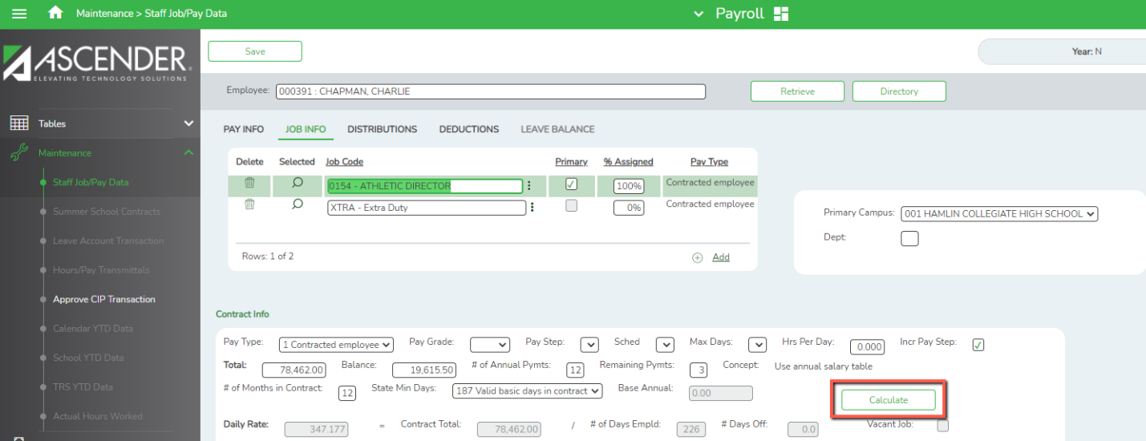

In the pop-up box, select Salary and Execute.
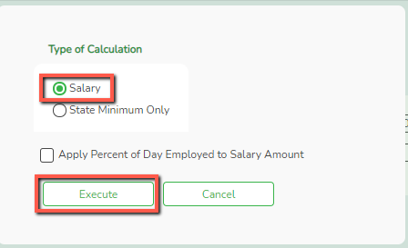

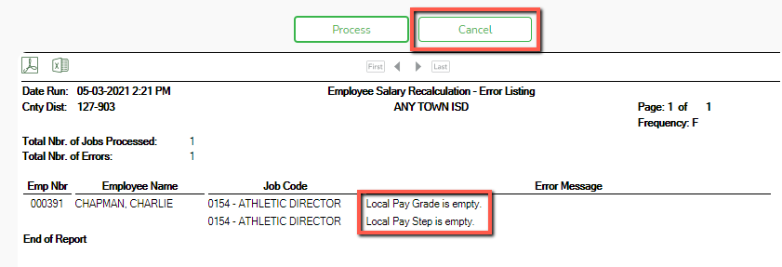
The report may display an Error Listing. If your employee is listed on this Error Report, then your salary calculations will not process and the extra duty will not be added as needed. Review the error listing to correct any error.

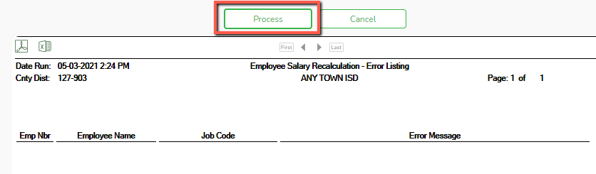
Once the report is blank, select Process to complete the calculations. G-Type Extra Duties will have been automatically added to the Contract Total.

_____7. Add or adjust distributions for the G Type - Extra Duty at Maintenance > Staff Job/Pay Data > Distributions Tab. The extra duty from the Pay Info tab is added as an Extra Duty attached to an existing job code on the distribution record.
- The first time the extra duty job is added, the user will need to distribute the salary by percent or amount. This means if you add the line for an Extra Duty that is $5000, you will want to decrease another salary line by $5000 to ensure the total for the contract is accurate.
- Refresh the percentages
- Save once you have the distributions completed.
Note: This will only have to be calculated manually the first year it is added to the employee’s job. Updates will be made through Mass Updates in subsequent years.
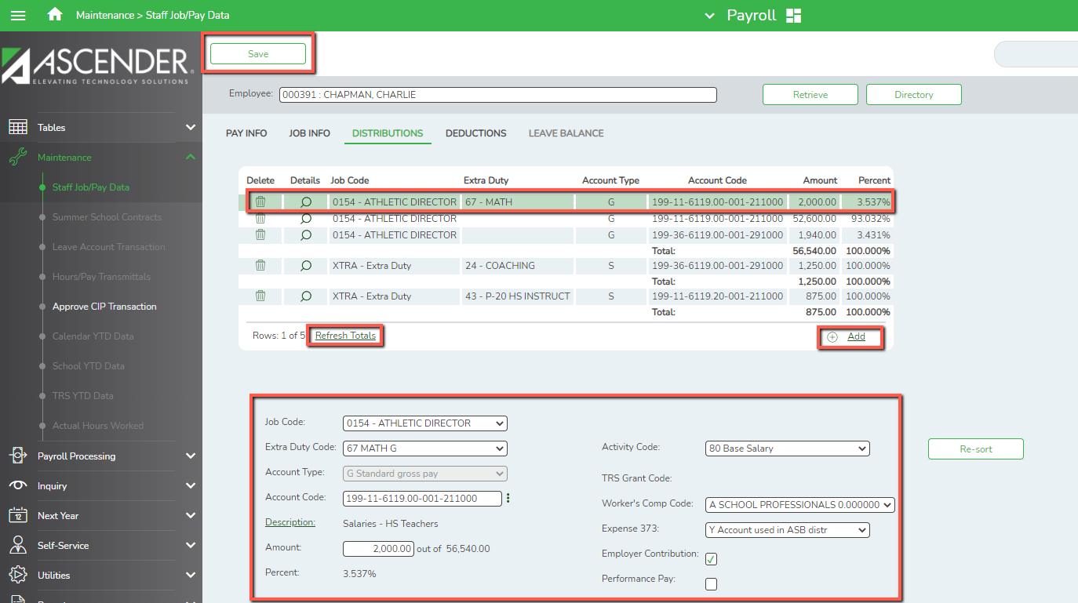
Note: Concerning the Addendum, only the jobs listed on the Job Info Tab will display on the addendum under the heading of Job Information. The G Type Extra Duty amount(s) will be included in the Contract Amount in the
Job Information section, but will also be listed as an Extra Duty in the Extra Duty Information section.

Updating an Existing Extra Duty -
_____8. Update the Extra Duty information such as amount, account code and TRS Member Position in Personnel > Tables > Salaries NYR > Extra Duty and Save.
Note: If no TRS Member Postion is selected, Ascender will default to a Code of 03 (Support Staff) when TRS reports are extracted.
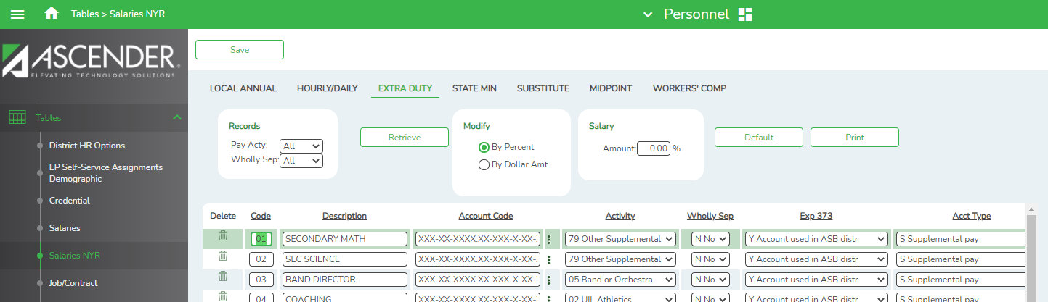
_____9. Mass Update the employee’s screen from Payroll > Utilities > Mass Update > Extra Duty tab. The Extra Duty tab allows users to add, change, and delete extra duty codes as well as alter the existing dollar amounts associated with the extra duty assignments. Once extra duty assignments are changed or deleted using this page, modifications are reflected in the individual extra duty records.
- Select the radio button to Change Existing Extra Duty Code Information and select the appropriate Extra Duty Code.
- If the Extra Duty is an S Type, the Amount, Remain Amt, and Remain Pymts fields will need to be filled in.
- If the Extra Duty is a G Type, only the amount will need to be populated. The Remain Amt and Remain Pymts fields will be grayed out as the system will automatically distribute the total over the course of the contract.
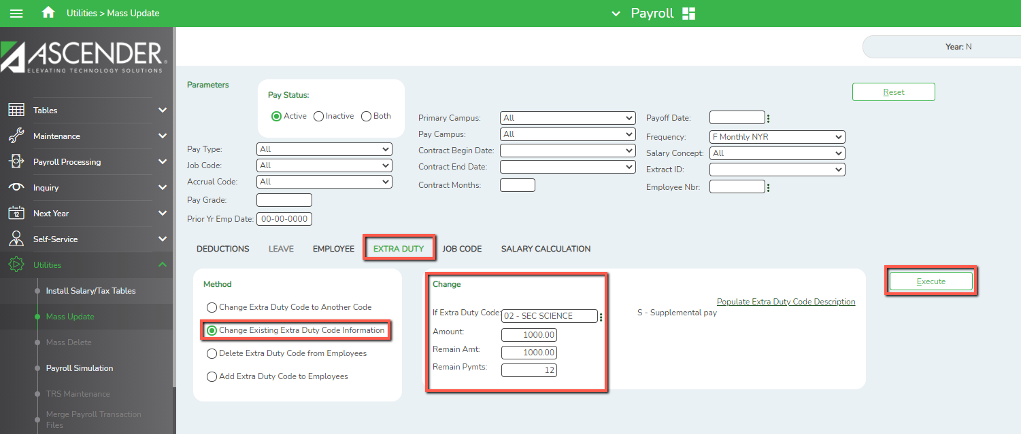

When you Execute, a preview of the employee(s) who have the selected Extra Duty code will display. Select Process at the preview.

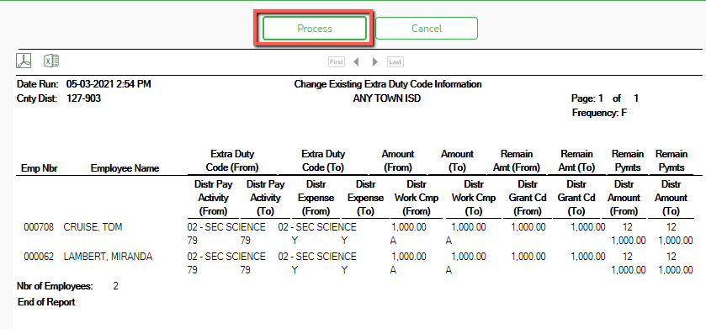

_____10. Perform Salary Calculations to get G Type Extra Duties added to the contract totals from Utilities > Mass Update > Salary Calculation tab. Select a Salary Concept, then select the employees you wish to do a salary calculation on, or leave blank for all employees.
Note: When you Execute, an error listing will display. Salary Calculations will not be performed on employees displayed on the report.
The employee’s Extra Duty information has now been updated and new percentages assigned on the Distribution Screen
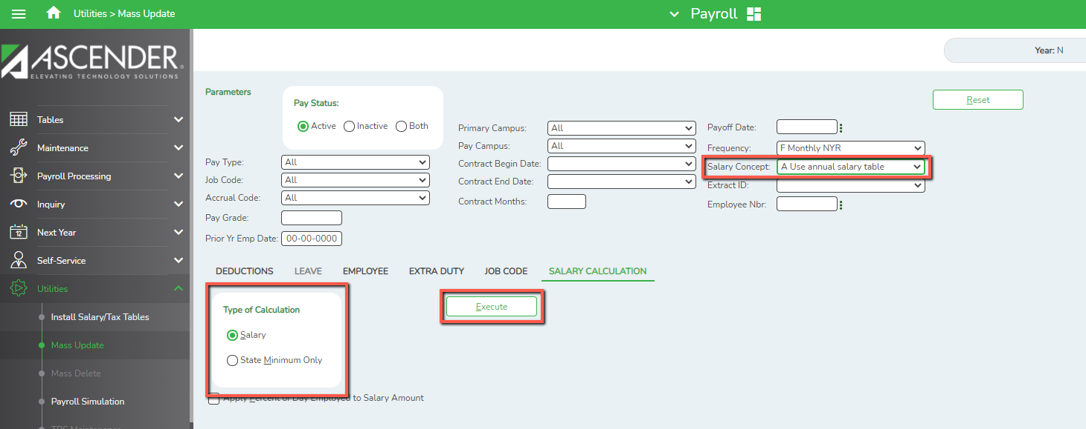

To Delete an Existing Extra Duty
From Maintenance > Staff Job/Pay Data, Retrieve the desired employee.
- Distribution Tab - Select Trash Can for that line you want to delete and Refresh Totals.
DO NOT CLICK SAVE YET.
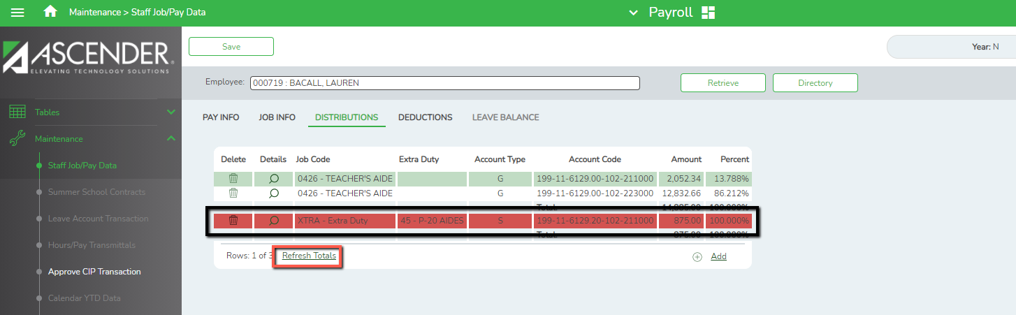

- Job Info Tab - If deleting All S Type - Extra Duties, select the Trash Can on the Extra Duty Line. If you will have other S Type, extra duties, then skip the Job Info Tab.
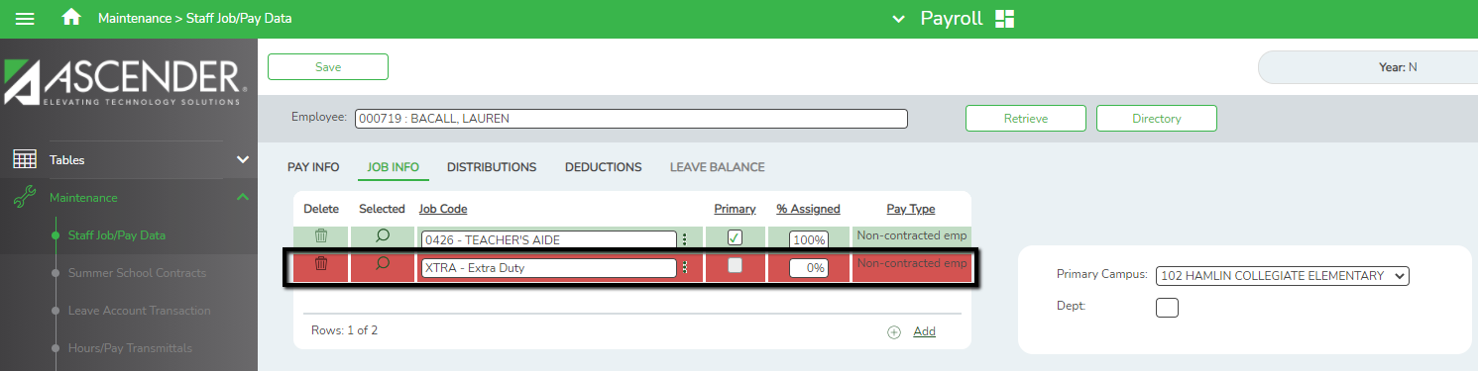

- Pay Info Tab - Select the Trash Can for all S types that you want to delete. Click SAVE.
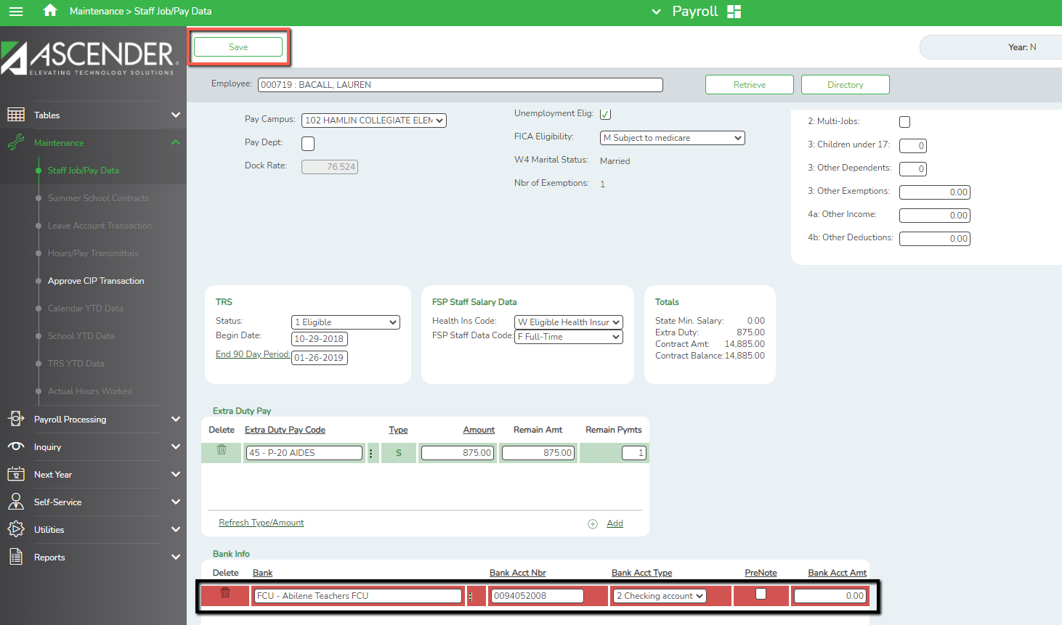

If you get the following Error, you have already sent information to Budget. Do the next step to correct.
JOB Info: Job Code EXTRA is already in use by the NEXT YEAR PAYROLL BUDGET table, it can not be deleted.

Sign into File ID C

To clear the temporary tables, change to Current, go to Payroll > Next Year > Copy CYR Tables to NYR. Select the ‘Clear NY Payroll Budget Only.’ Do not move anything to the right. Then Execute.
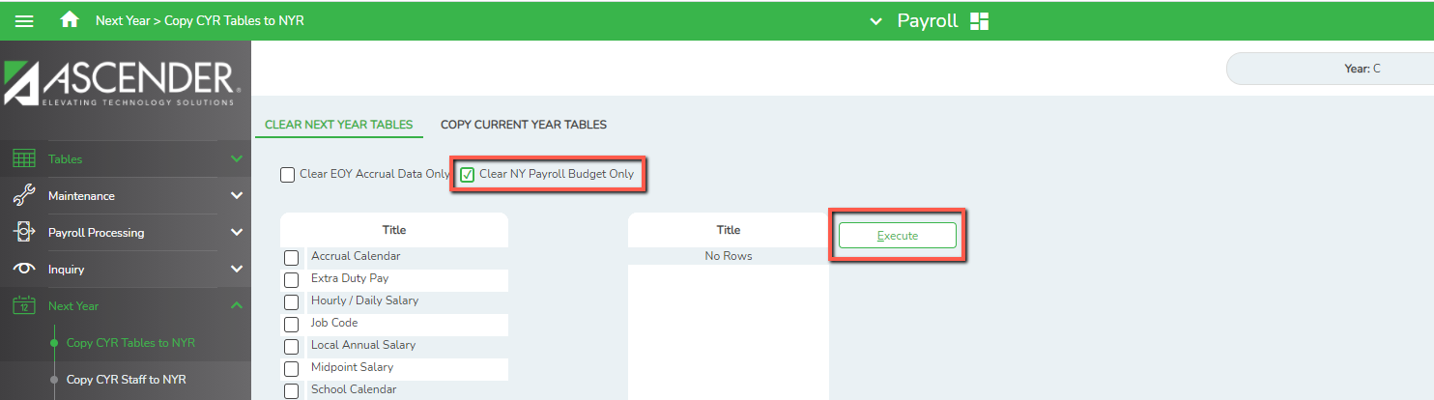
DO NOT Move Anything
Over to the Right.
Leave The Right Side
‘Title’ Blank.

Sign into File ID N

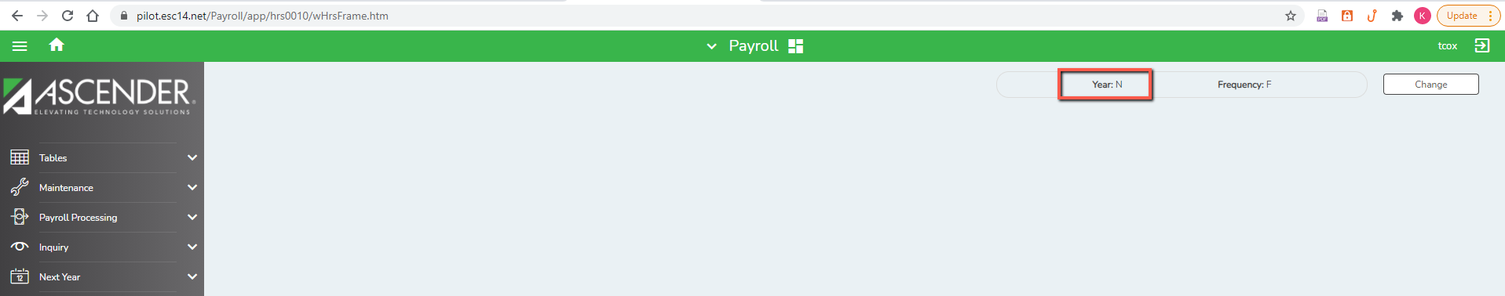

Repeat steps to delete the Extra Duties.

